Project title : Auto Ticket Classification using Flow Designer

Requirement Analysis phase-II

1. Customer Journey Map

Customer Journey - End to End Flow
This journey maps the experience of an employee from facing an IT issue to resolution using our automated system.
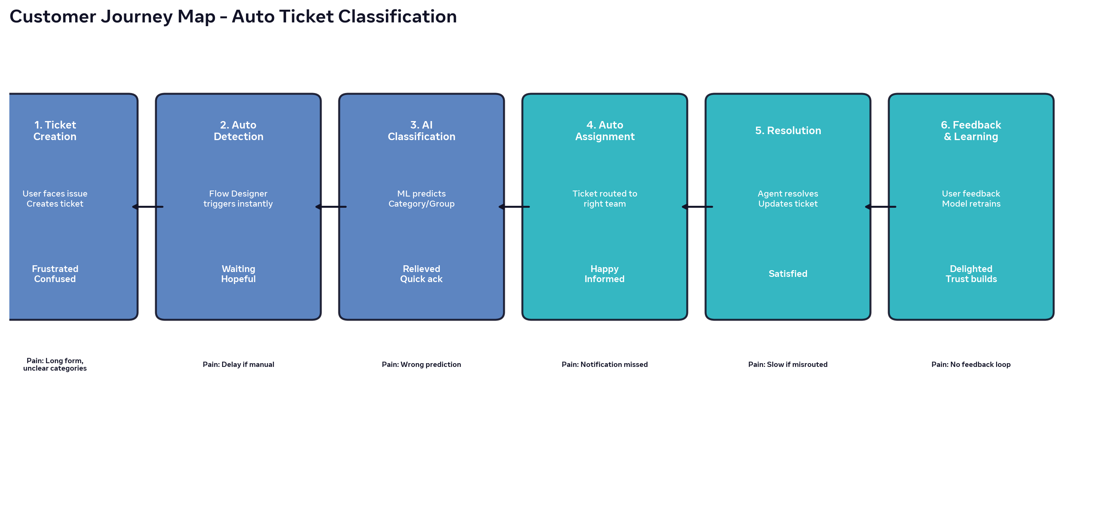
Stage | User Action |  | System Action |  | Emotion |  | Opportunity
Ticket Creation |  | User creates incident with description |  | ServiceNow record created |  | Frustrated |  | Simplify form, allow natural language
Auto Detection |  | User waits |  | Flow Designer triggers on create |  | Hopeful |  | Instant trigger, no manual wait
AI Classification |  | Receives auto ack |  | ML API predicts Category/Priority/Group |  | Relieved |  | 85%+ accuracy, <5 sec
Auto Assignment |  | Gets notification |  | Ticket routed to right group |  | Happy |  | Correct routing reduces MTTR
Resolution |  | Tracks status |  | Agent resolves with KB suggestion |  | Satisfied |  | Faster resolution
Feedback |  | Rates service |  | Feedback stored for retraining model |  | Delighted |  | Self-learning system improves

